Report

Laboratory Work 1

Dmitry Ladutsko

August 02, 2022

# 1. Prerequisites

## 1.1. Passwords Index

|  |  |  |
| --- | --- | --- |
| Password Group | Login Name | Password |
| Operation System | root | “rootadmin” |
|  | oracle | “oracleadmin” |
|  |  |  |
| Oracle System | sys | “sysadmin” |
|  | system | “sysadmin” |
|  |  |  |
| Oracle Users | All DB users | “%PWD%” |
|  |  |  |
|  |  |  |

## 1.2. Folder Paths Index

|  |  |  |
| --- | --- | --- |
| Path Group | Path Description | Path |
| Operation System | Oracle RDBMS – BIN | /oracle/app/oracle |
|  | Oracle Inventory | /oracle/app/oraInventory |
|  | Oracle Database Storage | /oracle/oradata |
|  | Oracle Install Directory | /oracle/install |
| Oracle | ORACLE_BASE | /oracle/app/oracle |
|  | ORACLE_HOME | $ORACLE_BASE/product/11.2 |
|  |  |  |
| FTP | ftp Incoming Folder | /ftp/incoming |
|  |  |  |
|  |  |  |

# Data Warehouse Architecture – Storage Layers

## 2.1. Task 01: CREATE Storage Objects

**The Main Task** is to create Physical Objects according yours Solution Proposal that was developed on Module 6 – Oracle DB. Introduction to DWH.

DDL SCRIPTS STOPRED ON GIT. I created 3 table for example, not to complicate.

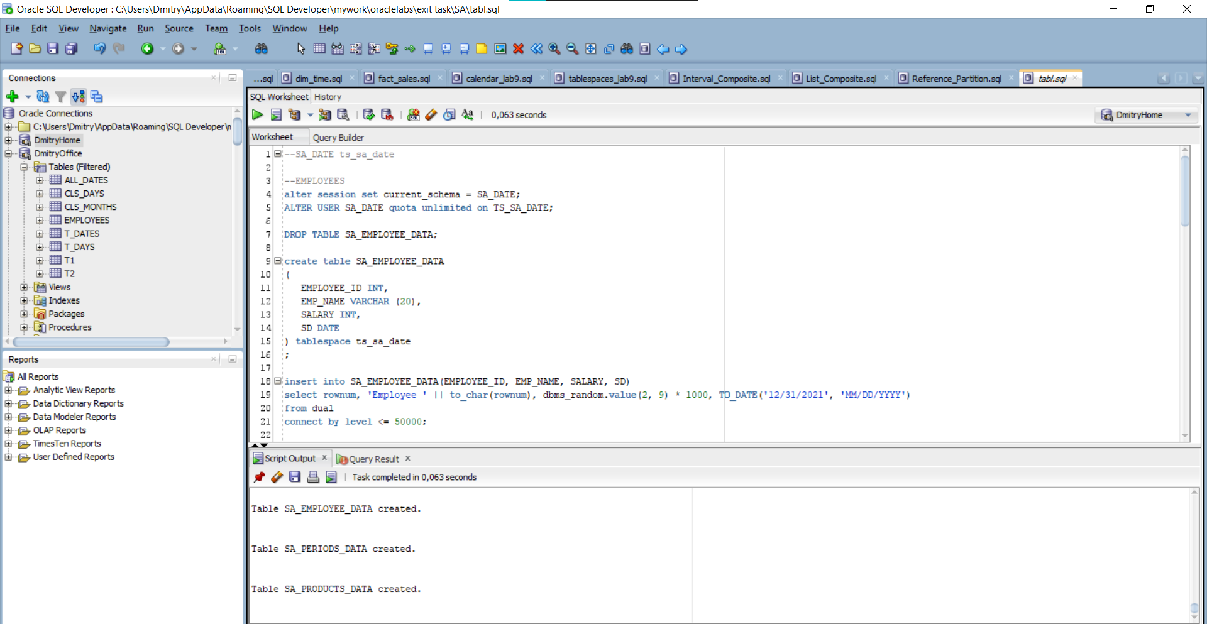

Picture 1 - Creating tables

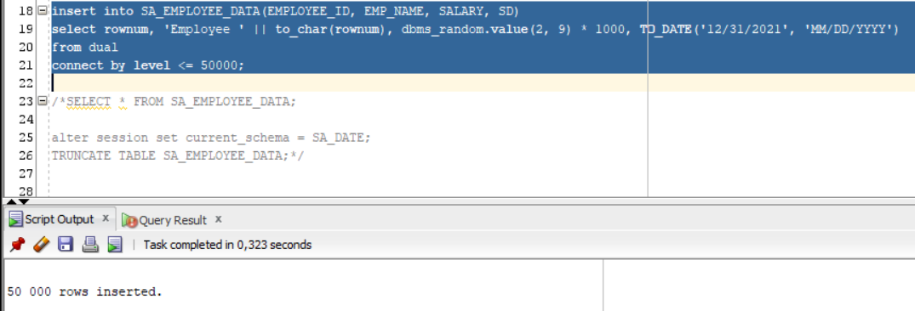

Picture 2 - DML

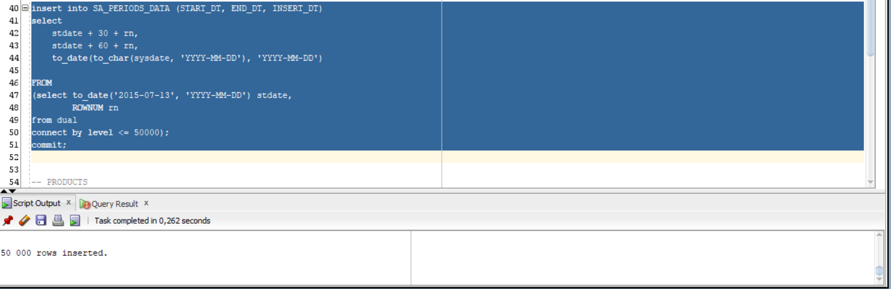

Picture 3 – DML

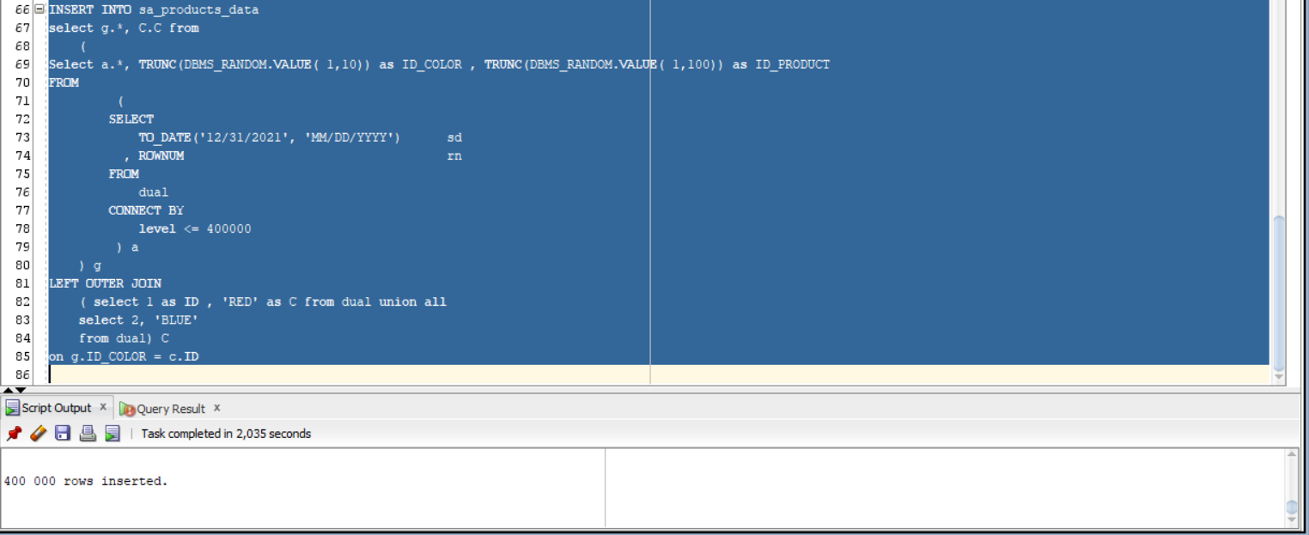

Picture 4 - DML

## 2.2. Task 02: Generate Test Data in Storage Layers

**The Main Task** is to generate test data on Storage layers objects, that was created on task 01.

I generated data using following scripts (also putted on GIT):

[1]

insert into SA_EMPLOYEE_DATA(EMPLOYEE_ID, EMP_NAME, SALARY, SD)

select rownum, 'Employee ' || to_char(rownum), dbms_random.value(2, 9) * 1000,

TO_DATE('12/31/2021', 'MM/DD/YYYY')

from dual

connect by level <= 50000;

[2]

insert into SA_PERIODS_DATA (START_DT, END_DT, INSERT_DT)

select

stdate + 30 + rn,

stdate + 60 + rn,

to_date(to_char(sysdate, 'YYYY-MM-DD'), 'YYYY-MM-DD')

FROM

(select to_date('2015-07-13', 'YYYY-MM-DD') stdate,

ROWNUM rn

from dual

connect by level <= 50000);

[3]

INSERT INTO sa_products_data

select g.*, C.C from

(

Select a.*, TRUNC(DBMS_RANDOM.VALUE( 1,10)) as ID_COLOR , TRUNC(DBMS_RANDOM.VALUE( 1,100)) as ID_PRODUCT

FROM

(

SELECT

TO_DATE('12/31/2021', 'MM/DD/YYYY') sd

, ROWNUM rn

FROM

dual

CONNECT BY

level <= 400000

) a

) g

LEFT OUTER JOIN

( select 1 as ID , 'RED' as C from dual union all

select 2, 'BLUE'

from dual) C

on g.ID_COLOR = c.ID

**I know we also could have use UNION ALL operators to generate data or SCROSS JOIN’s, but I chose this variant cause it much more optimized (less cost also)**

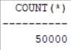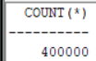

Picture 5 - Counts from tables

**Laboratory work summary:**

**At this lab** we have learned how (and which opportunities) gives as Oracle in generating Data for test e.g. It is absolutely clear that generating so much data is not needed every time we have to test SA layer(but also can use back – end p.l. to generate them easily). Nevertheless, this type is also quite acceptable if we have to test smth not to use some Back techs. All diagrams and scripts are stored in GitHub (link in README file in Labs folder)